Outcomes and measuring success (Development & Operations)
In the Idea and Impacts section of the Development & Operations application form, we want you to tell us about the outcomes you expect to result from your project, the measures you will use to measure their impact and the specific targets you will aim for as follows:
e.g.
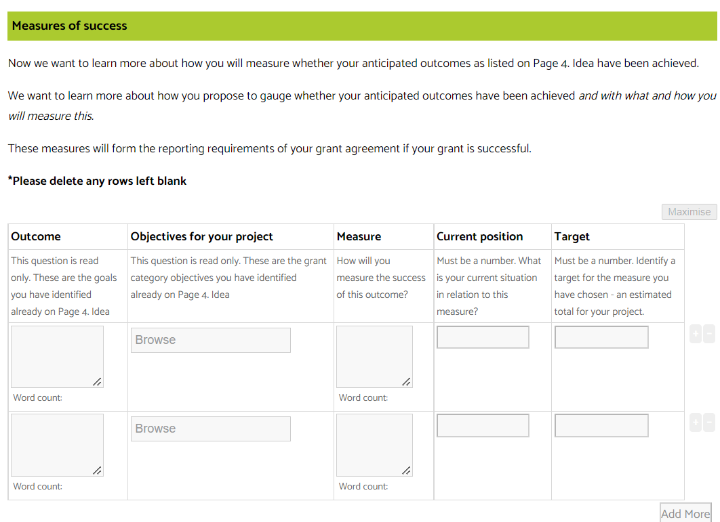

Outcomes

Outcomes are the changes you expect to occur for the beneficiaries of your project. Generally outcomes can be framed as an increase or decrease in one or more of the following:
- Skills, knowledge, confidence, aspiration, motivation (these are generally immediate or short-term outcomes)
- Actions, behaviour, change in policy (these are generally intermediate or medium-term outcomes)
- Social, financial, environmental, physical conditions (these are generally long-term outcomes)
For more insights into outcomes and evaluating your success, visit www.ourcommunity.com.au/evaluation.

Objectives
This is where you need to align your planned outcomes with the grant category objectives or outcomes. Select from the options provided in the drop-down list to let us know how your project will align with the goals of the grant category. Which of our outcome goals will your project contribute to? If multiple apply pick the most relevant.

Measures/Metrics
A metric is a measurement designed to indicate whether or not progress towards an outcome is occurring, and quantify the extent to which it is occurring. Here we would like you tell us which quantitative metrics you may be able to report on. How will you measure the success of your outcomes? These metrics will form the reporting requirements of your grant agreement if your grant is successful.
Metrics work best when they:
- Are quantifiable/numeric
- Are clearly defined and succinct
- Contain all the context needed to gauge and compare the result (e.g. unit [e.g. cm, metres, people, people-days, %, etc]; direction of change [increase; decrease; etc.]; timeframe [e.g. per month; per year; etc])
- Have been tested, and/or are in common use, and/or are commonly understood as a relevant and useful indicator of performance in a particular arena
- Are used sparingly - you are much better off to ""ask one good question and answer it reliably"" than try to track many things at once
- Relate to a clearly articulated outcome or activity.

Targets
These are the specific numerical goals you will aim for in relation to the metrics you have chosen, being an estimated total for your project. You will report on what you achieved in relation to these targets come reporting time so make them realistic and achievable.

Examples
Some examples of outcomes, measures and targets that you might include for Development & Operations grants include:
Outcome | Objectives for your project | Metric | Current position | Target
Increase the financial sustainability of our organisation | Enhance capacity, capability and long-term viability | Increase the number of financial members to our organisation | 80 | 100
Better reflect young people’s voices on our airwaves | Deepen engagement with identified communities | Increase the number of presenters at our station <26 years old | 5 | 10
Better reflect the local First nations community in our programming | Deepen engagement with identified communities | Increase the number of First Nation Australian presenters at our station | 0 | 3
Better reflect the diverse languages spoken in our local community in our programming | Deepen engagement with identified communities | Increase the number of culturally and linguistically diverse presenters at our station | 1 | 3
Better reflect people from our community with a disability in our programming | Deepen engagement with identified communities | Increase the number of presenters with a disability at our station | 1 | 3
Technology needs identified and implemented in future years | Develop longer term thinking and planning practices | Implement a technology replacement plan | 0 | 1
Reduce the environmental impact of our organisation | Strengthen governance policies and practices | Establish and implement an environmental policy and action plan | 0 | 1
Provide better professional development opportunities for our presenters | Enhance capacity, capability and long-term viability | Train volunteers to complete a certificate in journalism/media | 3 | 10
Reduced costs from shared infrastructure | Expand partnerships to maximise opportunities | Increase number of partnerships with other community media organisations | 1 | 3
Increased knowledge in how to respond to emergencies | Increase resilience through preparations for unexpected change | Develop a risk matrix and review once a year | 0 | 1

